<https://www-igi-global-com.ezproxy.lib.vt.edu/gateway/chapter/full-text-pdf/67047>

Information Needs for Hiking Based on the studies presented above,

this section briefly summarizes what information the user needs before the hike, during the hike, and after the hike.

**Before the Hike**

The most essential task before the hike is the planning of the hike.

For this task, the user will need information about the hiking area and both general knowledge about the topography and detailed knowledge about the routes and existing facilities such as fireplaces. The user will also want to add his or her own PoIs on top of the background map. The user will need to have tools for planning the hiking route, for example some kind of drawing tool or the possibility to select among routes provided by the service.

**During a Hike**

The user’s needs during the hike can be presented as a set of key questions:

• Where am I? This has to do with knowledge about the user’s position and orientation on a map

• How can I get from place A to place B? What is the shortest/fastest route?

• Where is the nearest fireplace, camping area, or other interesting facility?

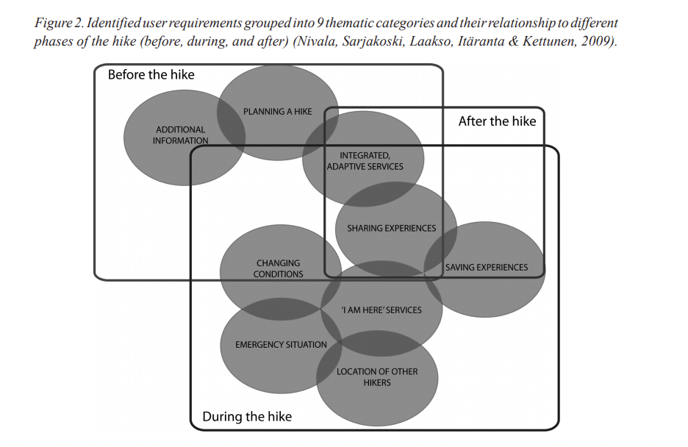

**After the Hike**

Users often want to save their routes, videos, and photographs and put their own markings on the map. They also want to share their experiences with other hikers

Motivation and mental well being

* Online questionnaire via social networking for quantitative analysis
* 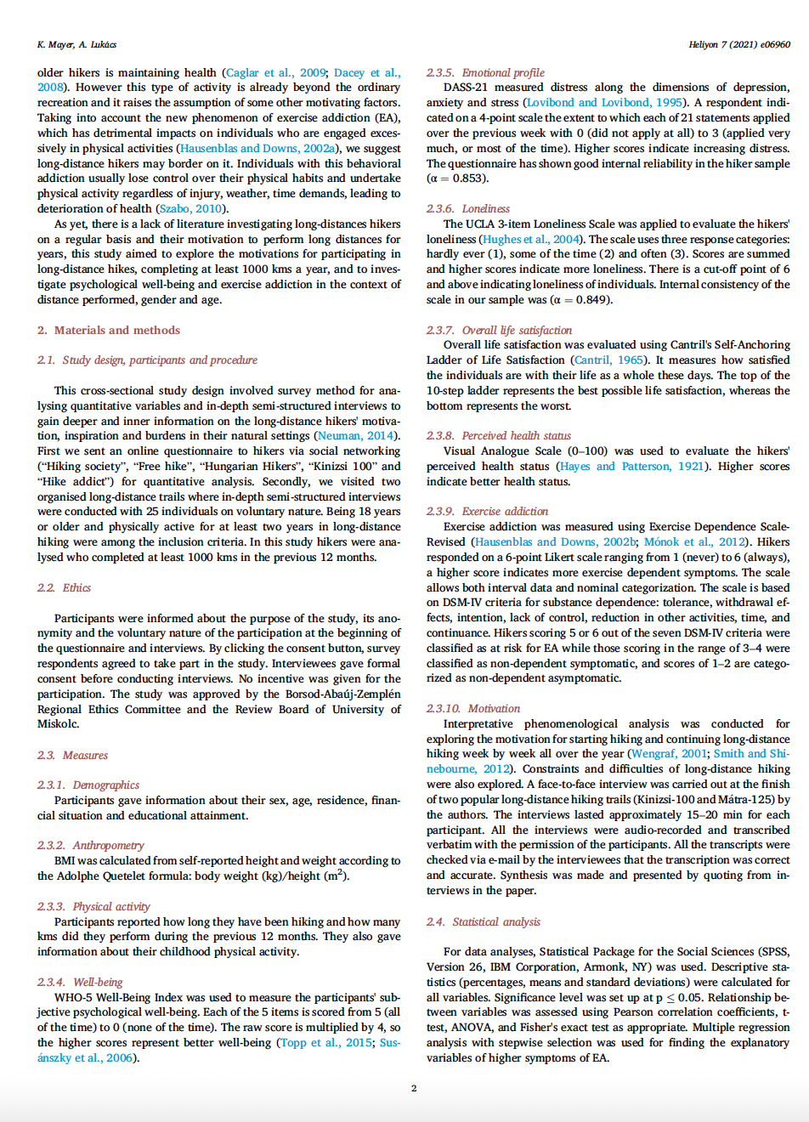

Why do people hike? Israel

* Questionnaire on INT over a year
* 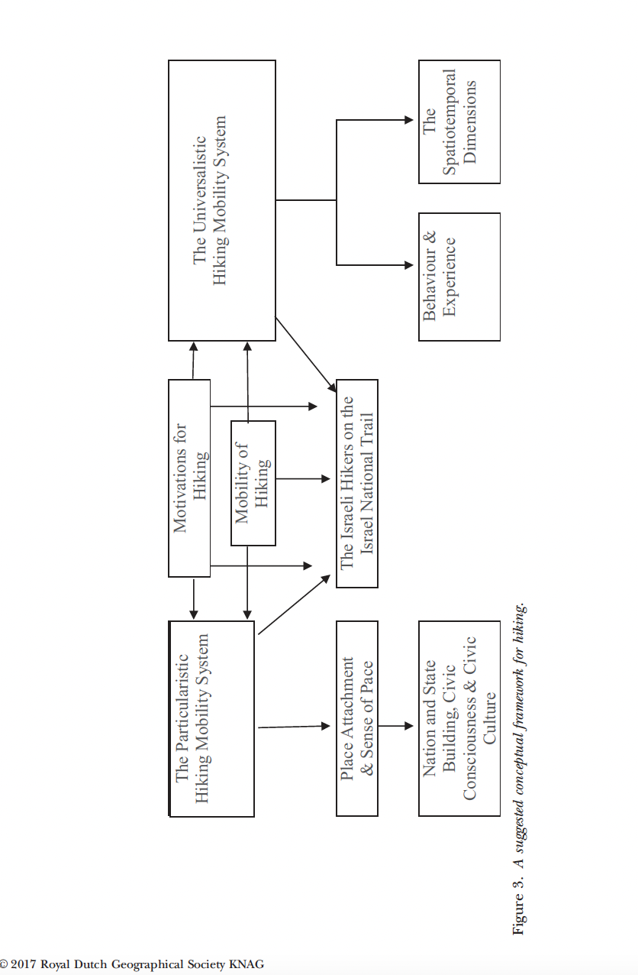
* 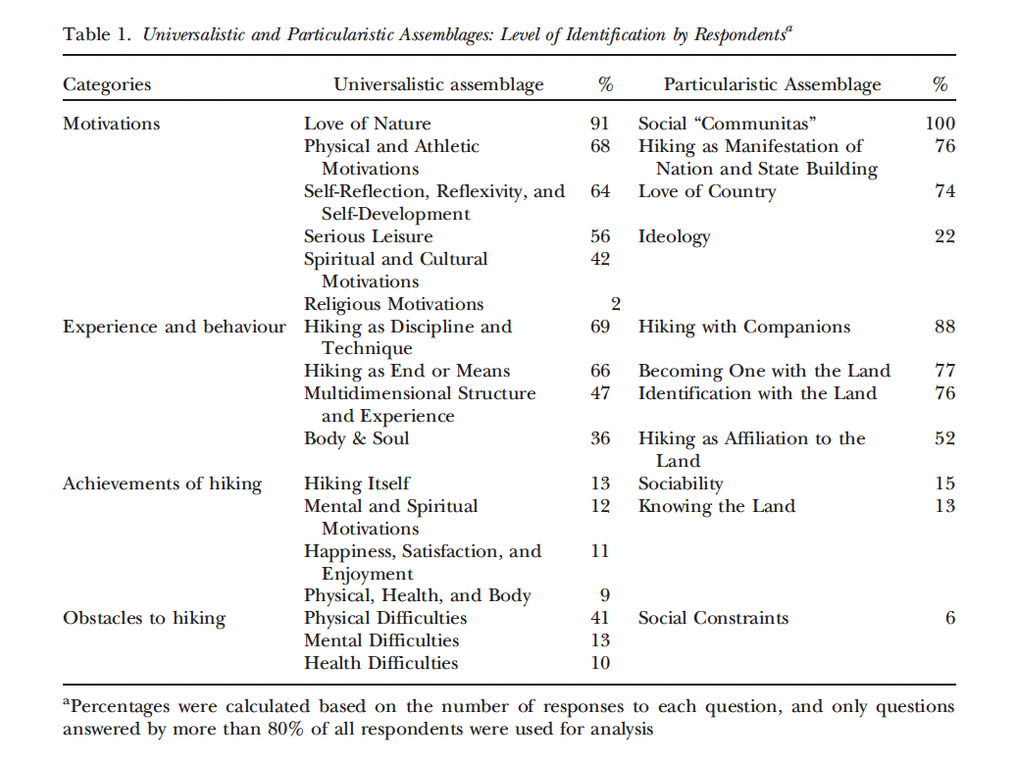

**Location based services and telecartography II : from sensor fusion to context models : 5th International Conference on Location Based Services and TeleCartography 2008, Salzburg**

<https://link-springer-com.ezproxy.lib.vt.edu/content/pdf/10.1007%2F978-3-540-87393-8.pdf>

* Questionnaire vs gps tracking data—monitoring pedestrian paths p. 100
* P 146 no landmarks used in navigation system
* To personalize a system adaptation is possible with regards to the following variables:
  + • The technological constraints of the user’s device

• The user’s physical context

• The user’s current activities

• The user’s personal characteristics

Past, present and future of tourist tracking

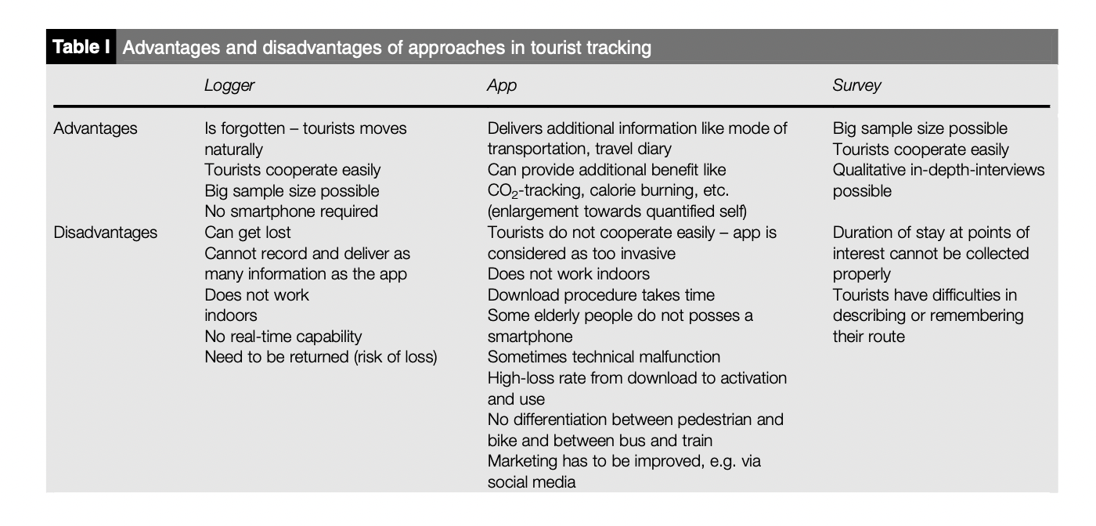

Mobile Crowd Sensing and Computing: When Participatory Sensing Meets Participatory Social Media

* 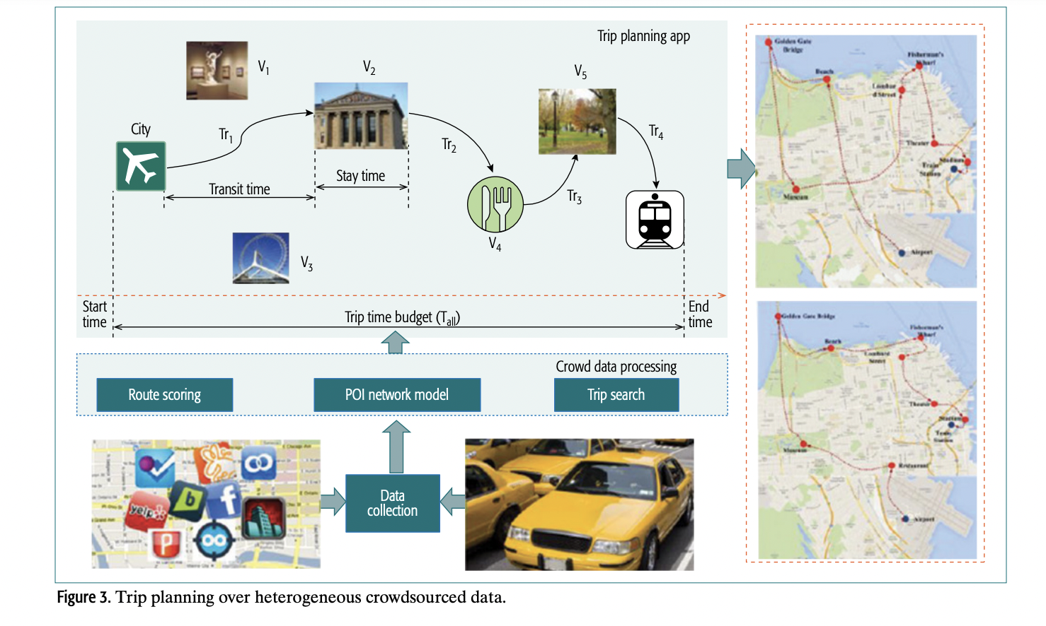

The places of our lives

* 6.1 Extracting Location Privacy-Sensitive Features We focus on four categories of features derived from four data types: 1. mobility data; 2. application usage; 3. Bluetooth; and 4. WiFi.

Activity-Aware Map: Identifying Human Daily Activity Pattern Using Mobile Phone Data

* characterizing the mobility not by geographic location but its associated spatial profile. This spatial profile-based mobility pattern, in turn, becomes a human activity pattern.
* we use anonymous mobile phone data collected during the period from July 30th, 2009 to September 12th, 2009 by Airsage (american telecomm company)
* the locations are estimated at the beginning and the end of each voice call placed or received, when a short message is sent or received, and while internet is connected.
* we need to extract mobility traces of each user from the mobile phone data.